- Workstation:
- Evidence off all specifications:
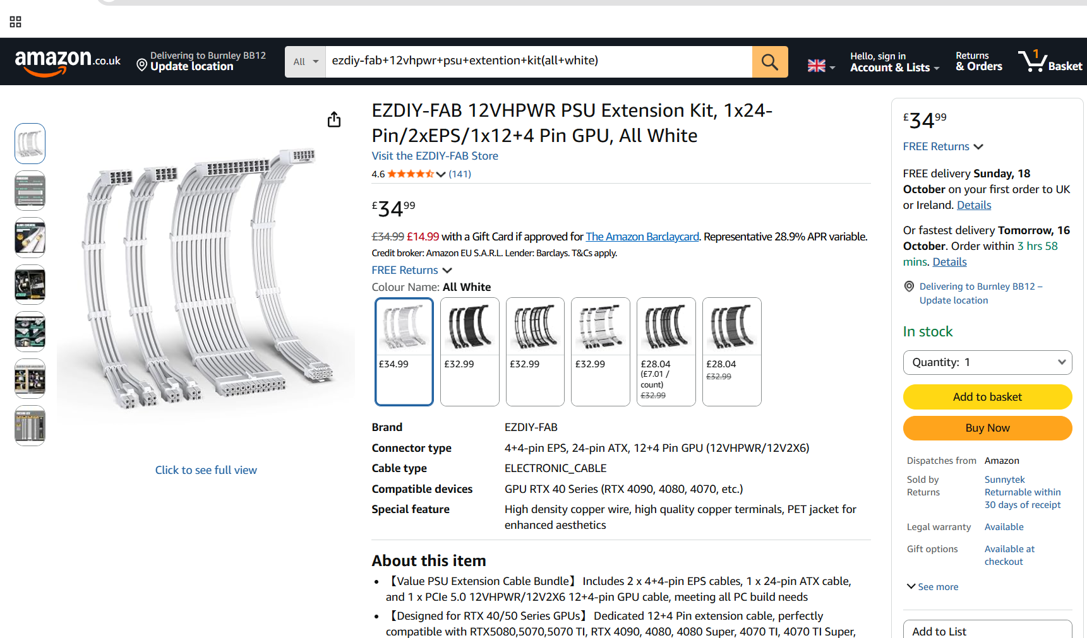

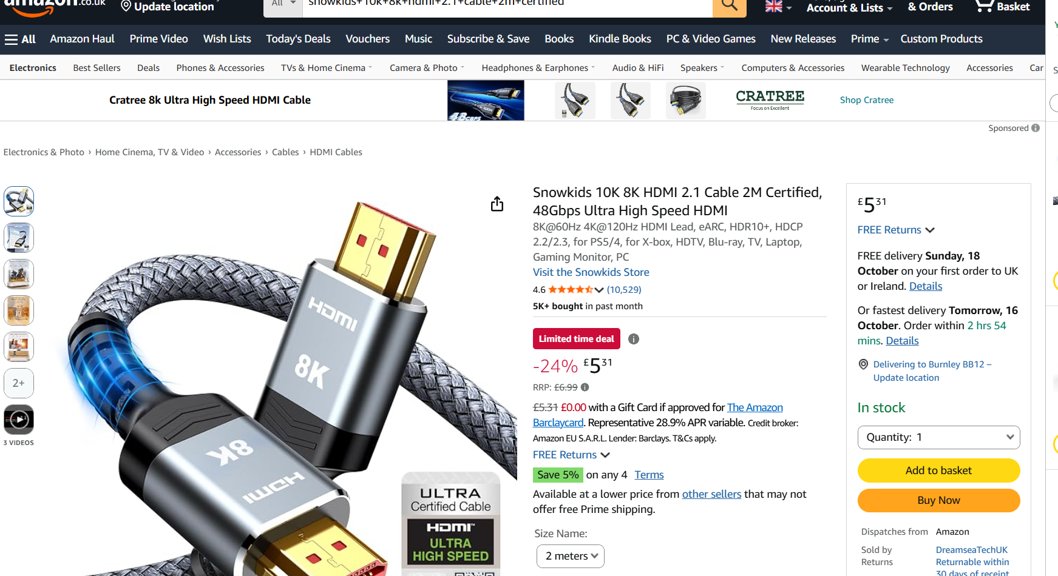

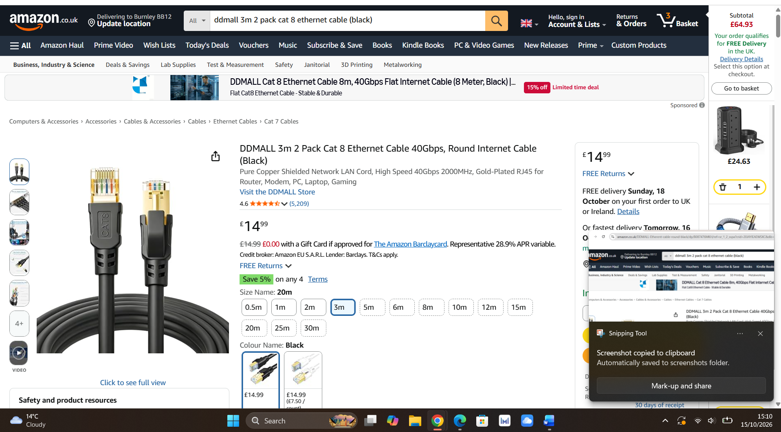
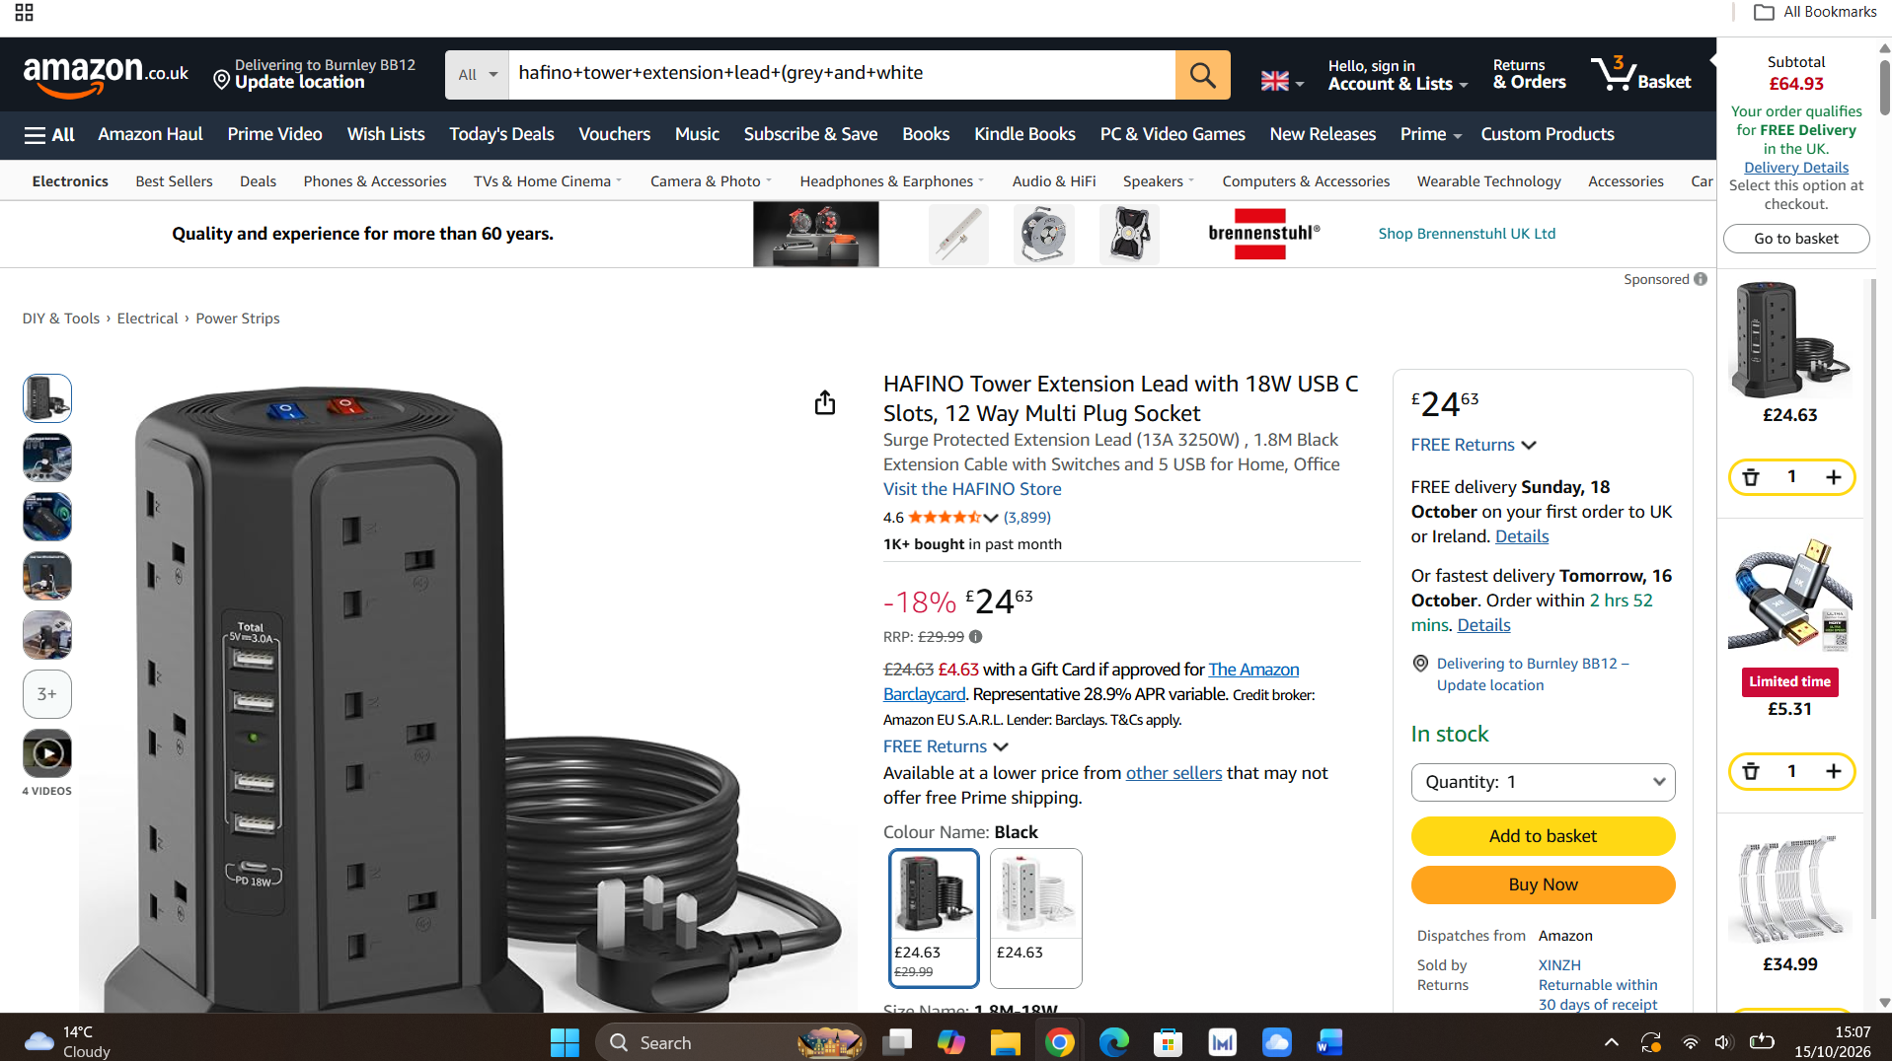

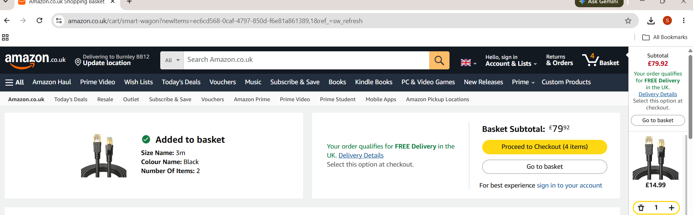
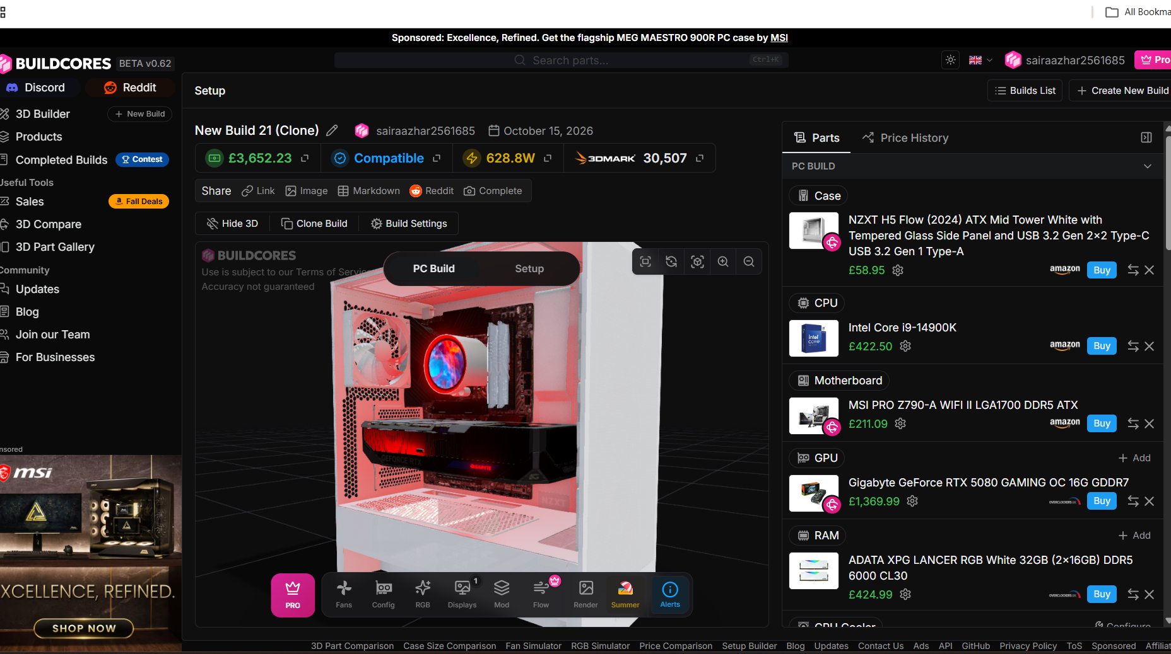

- Workstation justification:

Case — NZXT H5 Flow (White):

- Processor (CPU) — Intel Core i9-14900K:
- Motherboard — MSI PRO Z790-A WIFI II:
- Graphics Card (GPU) — Gigabyte GeForce RTX 5080 GAMING OC 16G:
- Memory (RAM) — ADATA XPG LANCER RGB White 32GB (2x16GB) DDR5 6000 CL30:
- CPU Cooler — NZXT Kraken Elite 360 RGB:
- Storage (Kingston KC3000 2TB SSD)
- Power Supply (Seasonic Focus 1000W)
- Case Fans — Arctic P12 Pro PST 120mm (x2):
- Mousepad — SteelSeries QcK Prism Cloth XL:
- Headphones — HyperX Cloud III S Wired:
- Mouse — Razer DeathAdder V3 Pro Wireless:
- Webcam — Logitech 4K Webcam:
- Keyboard — Redragon K745 Wired RGB:
- Cable Extension (EZDIY-FAB 12VHPWR Extension Kit - White)
- Ethernet Cable — DDMALL Cat 8 Cable (2-Pack):
- HDMI Cable — Snowkids 8K HDMI 2.1 Cable:
- Power Strip — HAFINO 12-Way Tower Extension Lead:
- Monitor — KOORUI 27" 1440p 144Hz Monitor:

- SQL Implementation:
Code Screenshots as evidence:
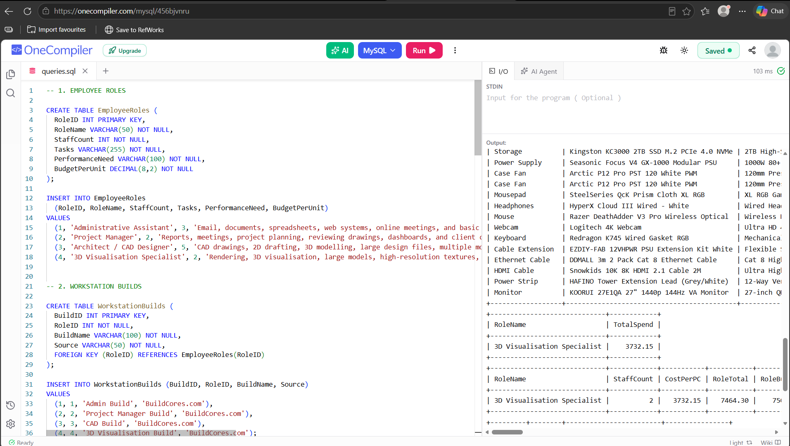

- Data Integrity:
- Primary Keys:
- Foreign Keys:
- Data Types:
- Data Security:
- Budget & Compromise Analysis:
- 32GB RAM Choice:
- Storage (2TB NVMe SSD):
- GPU Choice (RTX 5080 vs RTX 5090):
- Ethical & Environmental Considerations
Energy Saving and Efficiency:
Longer Hardware Life:
User Health and Comfort:

